Teams:
Paige, Darcey, Hayden, Jalen,
Amber, Geoff, Paetton
Charles, Jameel, Joe
Storm, Hope, Kira, Amy
Eric, BJ, Sam, Emily
Victoria, Tanner, Brittani, Andy

Each team must pick a team leader, note taker, and a recorder.
The team leader asks questions on behalf of the group.
The note taker takes the notes required to help solve the mystery.
The recorder records the official answers to the questions included in the game.
All team members must have this worksheet in their notebook. I will view the recorder’s worksheet for the answers from the team, so make sure you al agree with what the recorder writes.

Murder at Trout Lake
May 2013

You have all been called together because you were all star students in Mr. Bregar’s best field biology class. Mr. Bregar was found on the bottom of a lake while at a lake retreat for teachers. The detective’s initial report calls the death an accident. It states that he hit his head and was found with fluid in his lungs at the bottom of the lake. From this the detective determined that Mr. Bregar must have tripped and hit his head on a rock while walking his dog by the lake at night. The head wound made him unconscious and he drowned after falling in the lake. His wife and colleagues do not agree with the detective and have decided to look in to it themselves. That is why they have gathered all of you together. It seems that there are some clues that just don’t add up.

Sections from the coroner’s report:

“After shaving the victim’s head bruising was found on the back of his head. The bruise is circular. This bruising is consistent with a rock.”

“…the water that retrieved from his stomach had an accumulation of small zooplankton in his stomach. A picture of the dominant species is below.”

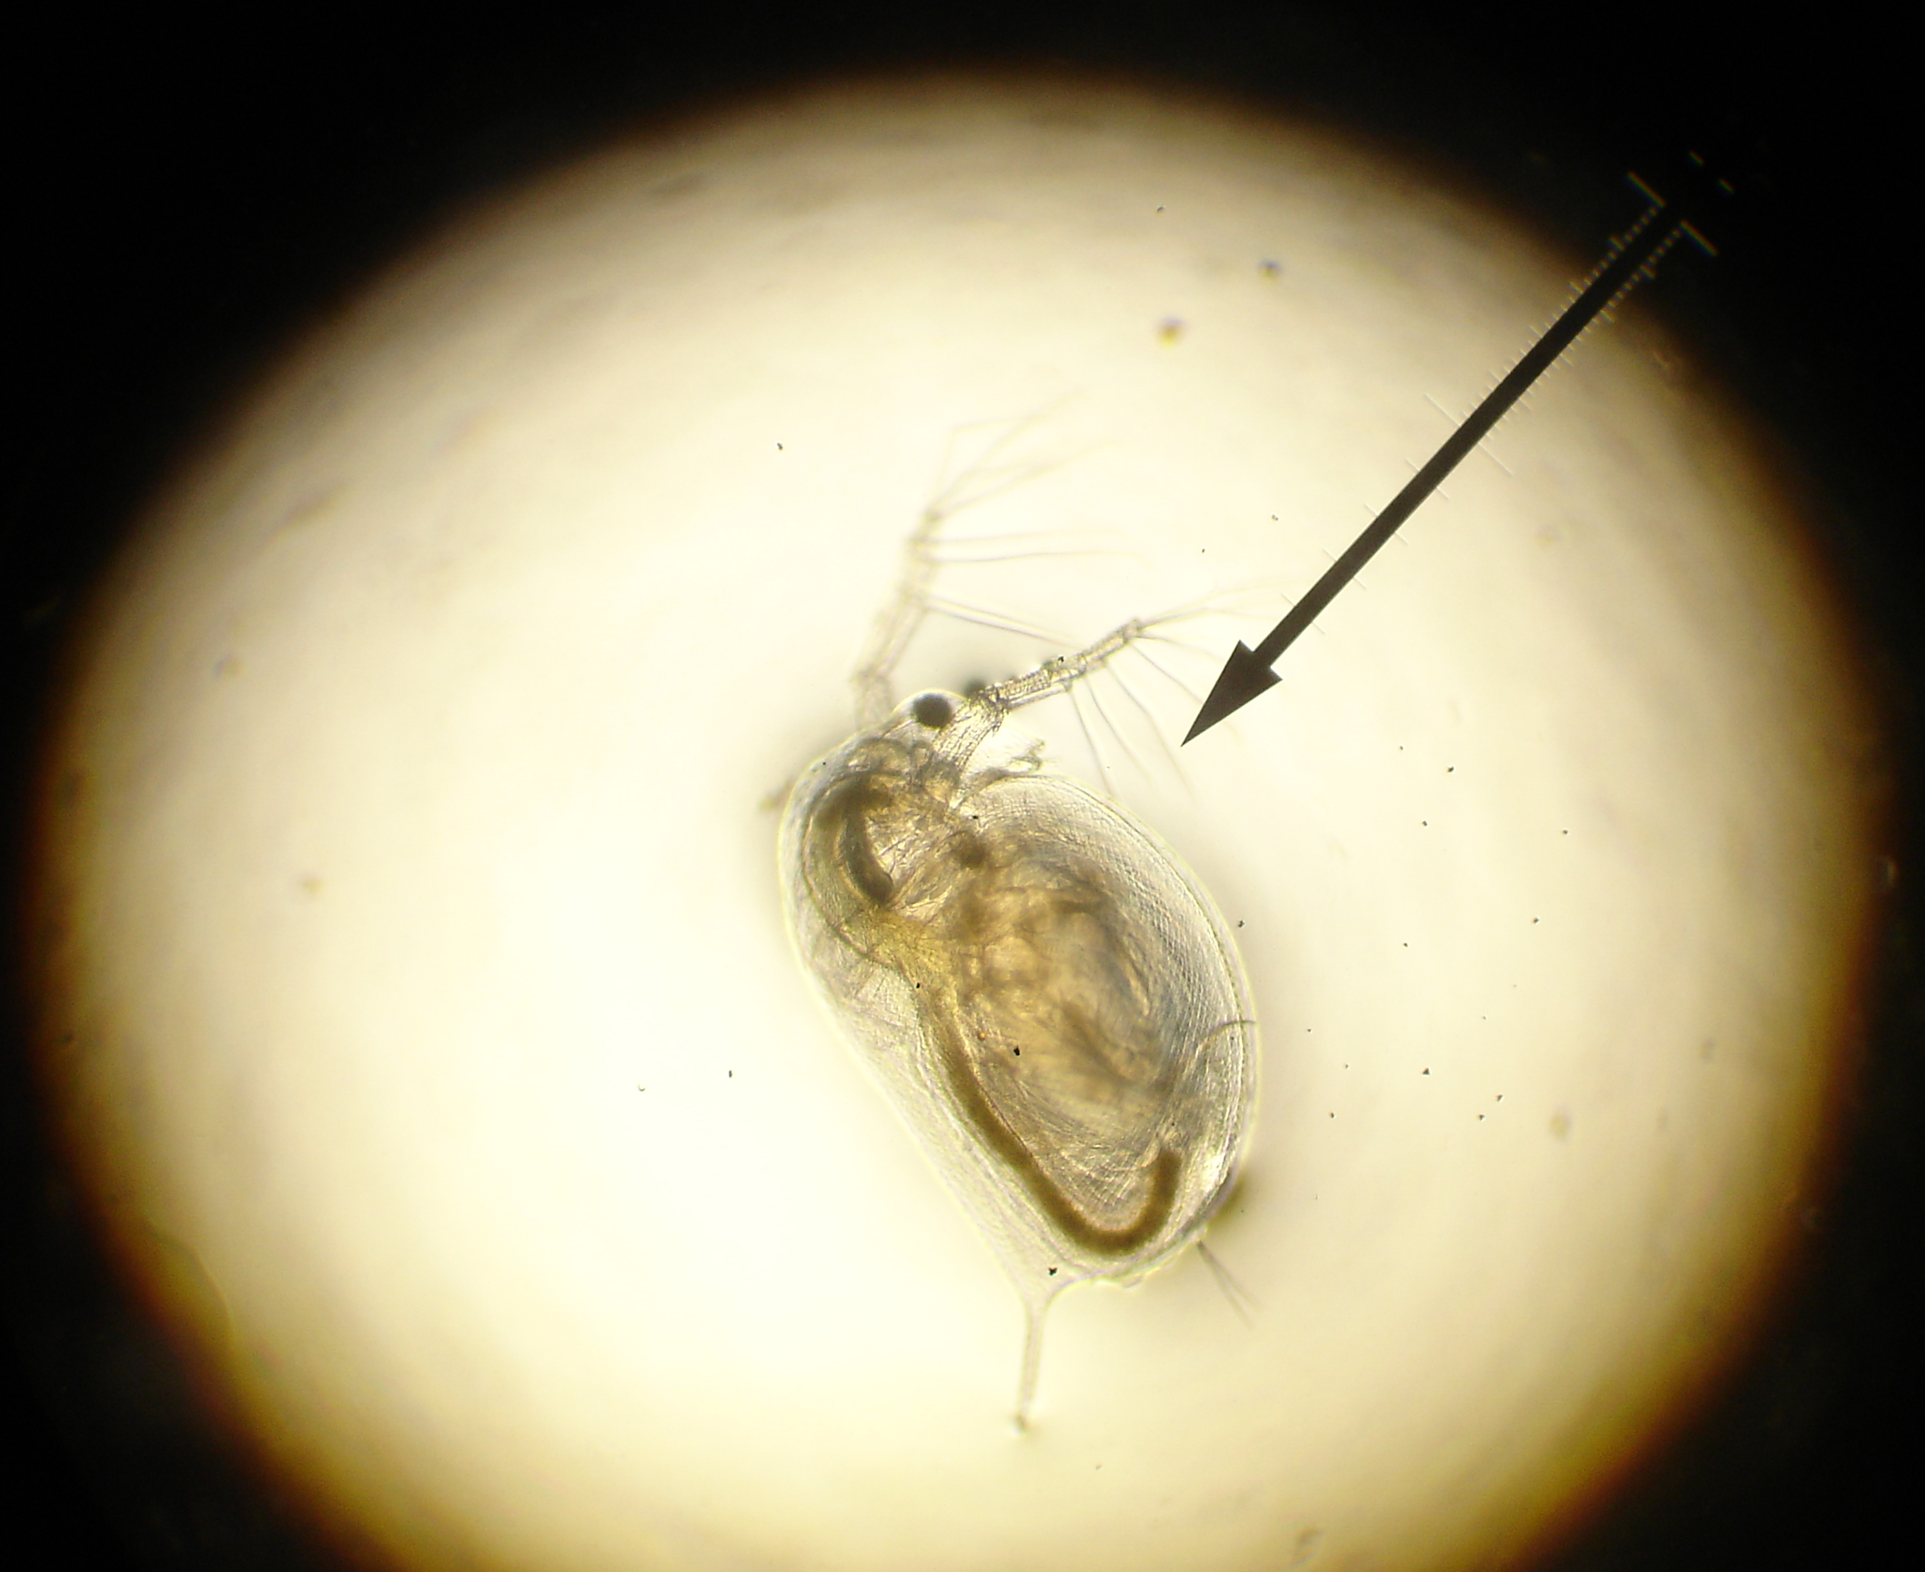

Based on the coroner’s report and the provided explanation (Mr. Bregar tripping and drowning while walking his dog) why might Mr. Bregar’s wife and colleagues be suspicious?

Discuss in your teams. Ask Ms. Ranelletti yes or no questions to get more information about the lake that may help you figure out why these things just do not add up.

Are you suspicious?

---------------------

Murder at Trout Lake
May 2013

Mr. Bregar’s wife has asked everyone staying at the lake to come and tell you what they know about that night and where they were on the night Mr. Bregar died. Most of the guests were Mr. Bregar’s colleagues and want to help figure out what happened. To help you understand the environment in question here is a list of water quality parameters that have been gathered to help you determine who is lying and who is telling the truth.

The lake is fed by a small freshwater river that enters the lake on its north side. The lake also gets quite a bit of its water from spring snowmelt. The lower section of the river is used to cool an industrial building. Part of the water is taken from the river and used to cool systems before being put back in the river with some industrial waste. Water flows out of the lake and into a second river on the south side. That river is small and hard to reach so any reference to a river is the north river.

Water Quality of the Lake | Water Quality of the North River
Turbidity: 350 NTU | Turbidity: 10 NTU
pH: 4.00 | pH: 6.00
Temperature: 12 degrees Celsius | Temperature: 15 degrees Celsius
Dissolved Oxygen: 2 | Dissolved Oxygen: 6
Depth: 10 feet

Use the water quality details above to explain why you think the statements below are the truth or lies. As a team you can ask Ms. Ranelletti yes or no questions for help on the clues. It is thought that Mr. Bregar died at sunset or just after.

Colleague Mr. Kanter
Background – Mr. Kanter was fired from teaching after taking some bad advice from Mr. Bregar. He still works at CVHS in the library and is friends with most of the science teachers, although his relationship with Mr. Bregar was strained. He also works with the Mountain Rescue program after Mr. Heilman introduced him to it.

Where were you?
That day I had decided to go fishing. I went up the lake to look for some trout. I tried many different sites along the bank but could not catch a single fish. I decided to quit once it got dark. I walked back and stopped by the general store for a soda and chatted with Ms. Hee.

Do you think he is telling the truth? Circle yes or no
Explain why and relate to at least one water quality detail from the table.

Anything else?
“I think that someone killed Mr. Bregar. This morning I was walking around the lake to calm down from the news of his death and I saw a large log sitting on the bottom of the lake. I took a closer look and I am pretty sure it looked like there was blood on it. I think someone hit Mr. Bregar in the head with the log and then threw it in the lake.”

Colleague – Mr. Beran
Background – Mr. Beran still teaches at CVHS. He has started an award winning junior aquarist program. He enjoys fishing on the weekend with Mr. Kanter. He is good friends with Mr. Bregar and thinks it is a compliment that people still get them confused.

Where were you?
“I was down at the lake at sunset tossing rocks into the lake with my daughter. She had wanted to go swimming but I told her it was too cold. I let her splash her feet in the water until I realized that her feet were getting covered in dirt and clay just from the water. Once it got dark we went back to the lodge and I put my daughter to bed. I met Mr. Kanter to talk about Chemistry standards after that.”

Do you think he is telling the truth? Circle yes or no
Explain why and relate to at least one water quality detail from the table.

Anything else?
Mr. Kanter was looking for Mr. Bregar earlier that evening. I had not seen Bregar but I told him to check Mr. Kirsch’s room since I heard them arguing in there earlier that afternoon. Ms. Hee went for a run around the lake that night so I checked in on her daughter when I got back to the lodge.

Colleague – Mr. Heilman
Background – Mr. Heilman was a student teacher for Mr. Bregar back in 2008. Since then he has been a substitute teacher in the Corvallis school district and also continues to work with the Mountain Rescue program. He is still seen quite a bit at CVHS since he is a substitute for Ms. Hee quite frequently.

Where were you?
“I went fishing at the lake in the early evening. Spring is the best time to fish this lake so I spent quite few hours fishing. I caught a couple large trout to BBQ for dinner. I went back to the lodge, changed, and joined Ms. Stroud and Ms. Linhares for dinner.”

Do you think he is telling the truth? Circle yes or no
Explain why and relate to at least one water quality detail from the table.

Anything else?
“I saw Mr. Beran cutting down tree limbs yesterday. It seemed quite odd.”

Colleague - Ms. Stroud
Background – Ms. Stroud has been a very successful principal at CVHS for many years. She enjoys working with the students and teachers. This is the first year she joined the teachers on the retreat. She came along to help figure out why there seems to be so much tension among the science teachers.

Where were you?
Ms. Linhares and I met on the lodge porch to discuss the upcoming staff calendar. It was a beautiful night and we could hear the frogs chirping at the lake.

Do you think she is telling the truth? Circle yes or no
Explain why and relate to at least one water quality detail from the table.

Anything else?
We ate dinner later that night with Mr. Heilman who has been enquiring about jobs at CVHS. We had mentioned there were currently no jobs available but agreed to dinner. He brought some fish to BBQ that he said he had caught earlier that evening at the lake.

Colleague Ms. Hee
Background – Ms. Hee is still teaching at CVHS with many of the others that are at the lake. She still enjoys teaching but has also developed a love for motorcycles. Besides her family, motorcycles are her passion. She takes frequent road trips and feels comfortable doing that since Mr. Heilman is available to student teach.

Where were you?
“I went for a run around the lake just before sunset. Once it got dark I stopped by the general store by the lake for some water, but I had forgotten my wallet so I just drank from the pump that the storeowner told me pumps water from the lake. It was very good water!”

Do you think she is telling the truth? Circle yes or no
Explain why and relate to at least one water quality detail from the table.

Anything else?
“This afternoon I saw Mr. Bregar and Mr. Heilman head up the river with fishing poles and water quality equipment.”
Colleague – Mr. Kirsch
Background - Mr. Kirsch is good friends with Mr. Bregar. They have taught classes together for 8 years. Their families are friends and they spend vacations together. Recently, Mr. Kirsch was planning to ask Mr. Bregar to stop teaching their Physical Science and Technology class. Together they won awards on their collaborations but their have been rumors that Mr. Kirsch may be tired of sharing the spotlight.

Where were you?
“I went for a swim in the lake at sunset. I was in the water for about 30 minutes so when I got out it was getting pretty dark. I saw Mr. Beran and his daughter after my swim and walked back with them to the lodge.”

Do you think he is telling the truth? Circle yes or no
Explain why and relate to at least one water quality detail from the table.

Anything else?
“I have been working with Mr. Bregar on measuring the water quality of the lake. This morning there was a missing turbidity meter. Maybe Mr. Bregar went to the lake to take a sample.”

Summary

List the liars:

List who is telling the truth:

Do you know who did it?

Who do you think killed Mr. Bregar? ______________________

Why do you think so?

What was his/her motive?

What was the murder weapon?

The team leader must submit the above information to Ms. Ranelletti. She will write yes or try again. If you get it correct please do not tell the other students. Mr. Bregar’s ghost thanks you for solving his crime.

